**CONTENT MANAGEMENT SYSTEM**

**Admin Login Page**

Username: admin

Password: admin

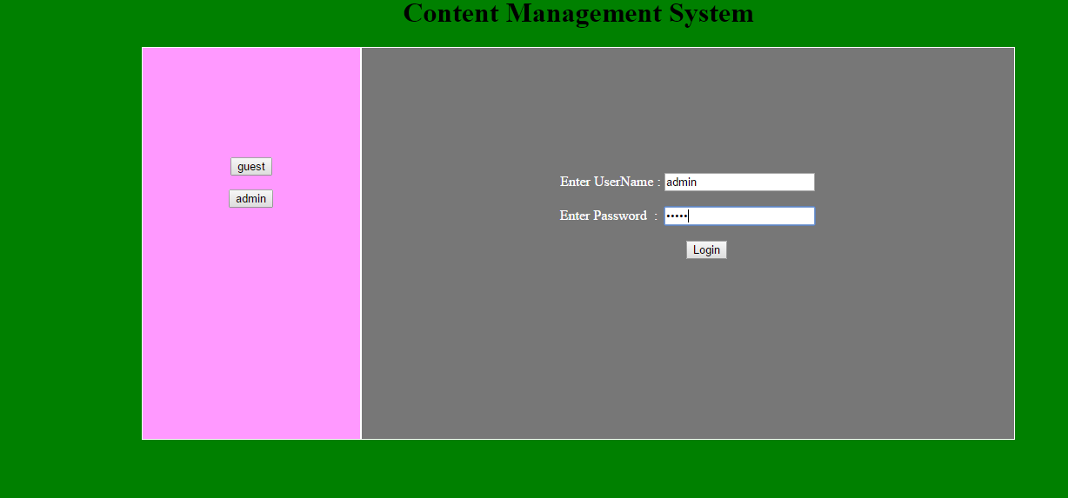

**User Login Page**

Any User can be login

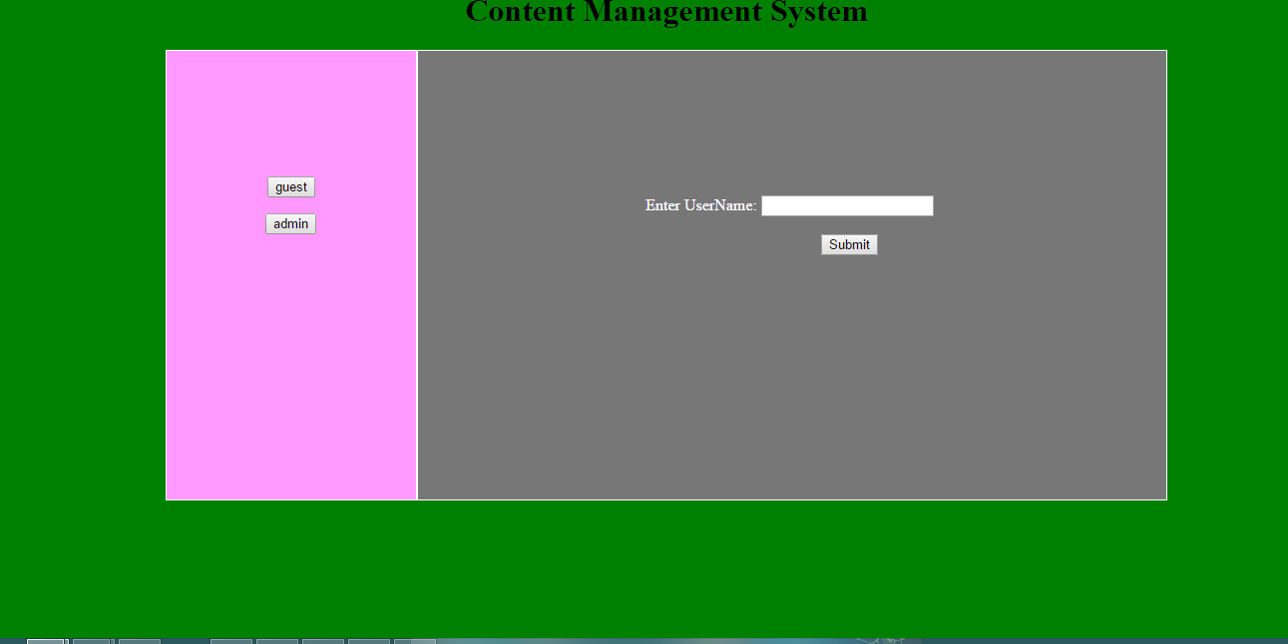

Admin can add blog and give the Title and description(Only Admin)

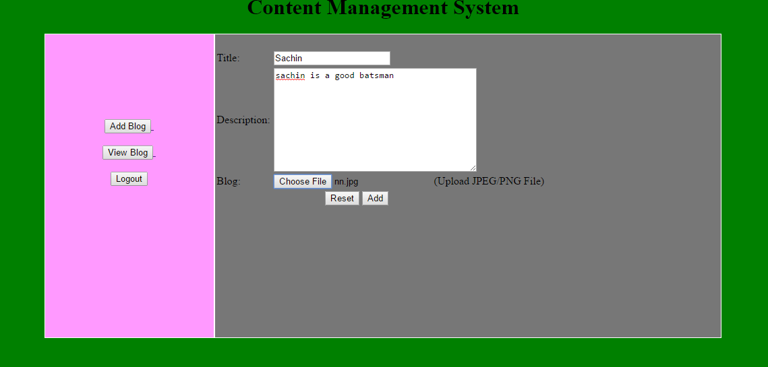

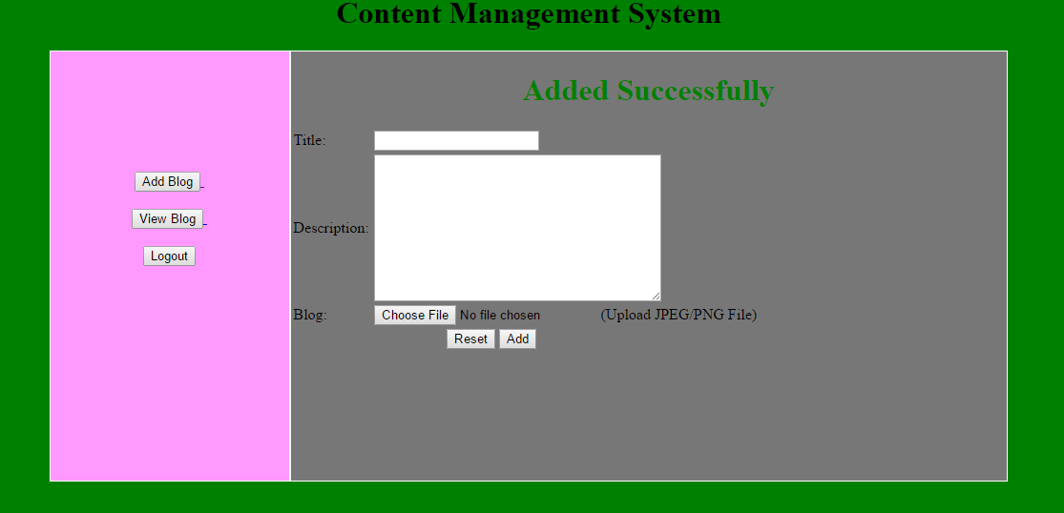

Admin can view the blog and user Comments

User can be view the blog & user comments and give the comments

And twitter about the blog

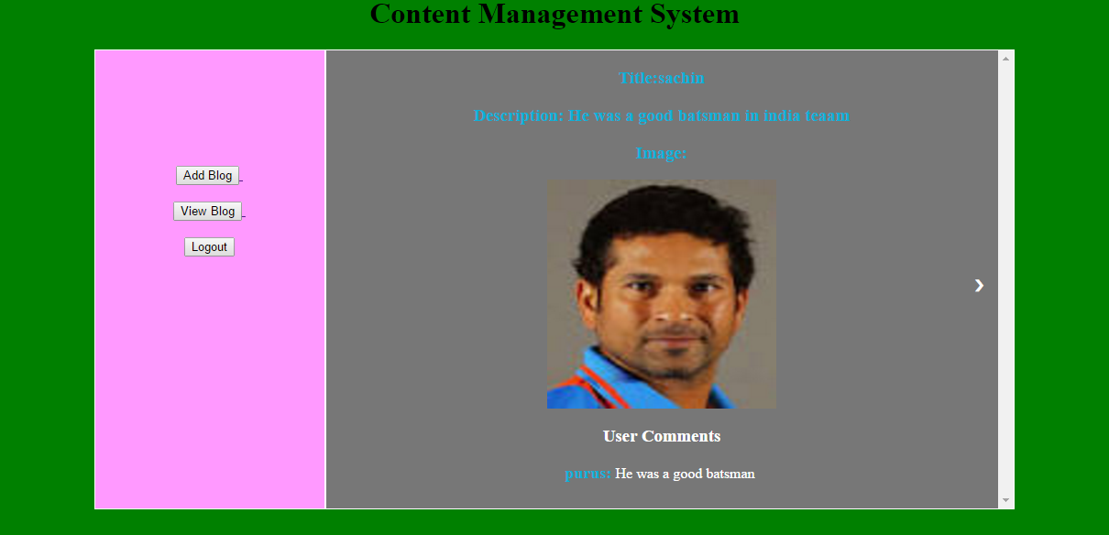

User can be view the next blog and give the comments

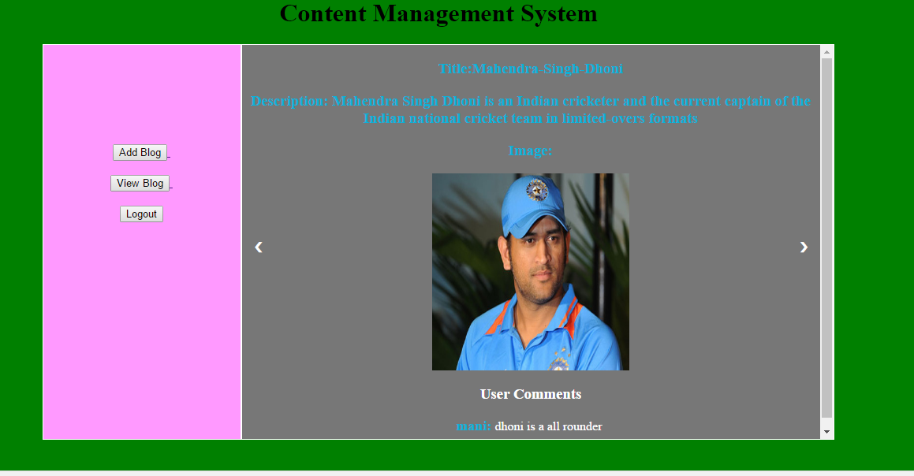

User can be view the blog & user comments and give the comments

And twitter about the blog

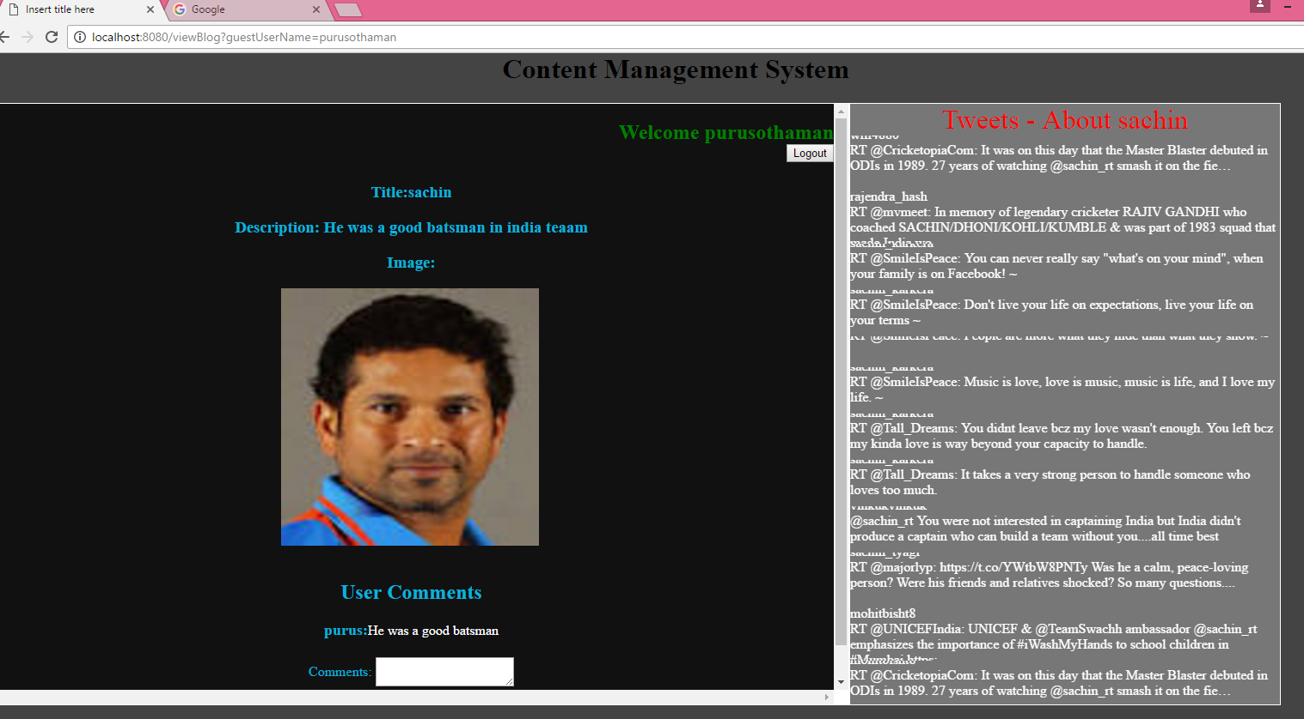

User can be view the next blog and give the comments

